User Experience Engineering

Widanagamachchi L.L. IT15098474

Checker Game Application

For Disabled People

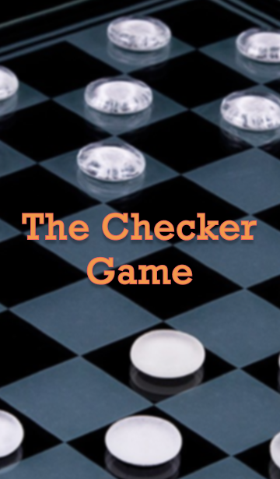

Contents

1

Page No

01.) Introduction 3

02.) Lab Assignment – 02

2.1) Identified Problem 4

2.2) Suggested Solution 5

2.3) Design of the Application 6

2.4) Business Value 7

03.) Lab Assignment – 03

3.1) Business Goals 8

3.2) Competitors 10

3.3) User Segments 12

3.4) User Persona 17

3.5) Conducted Survey Questions 19

3.6) Survey Results 21

3.6) Responses 27

04.) Lab Assignment – 04

4.1) Information Structure 28

4.2) Conceptual Model 29

4.3) Error Handling Mechanisms 30

4.4) Journey Map 34

05.) Lab Assignment – 05

5.1) Wireframes 35

5.2) Mockups 39

06.) Suggestions from the user 44

2

Introduction

3

**“YOU ARE YOUR ONLY LIMIT”**



Each and every one of us like to spend a normal life. But unfortunately some of us does not have that chance due to many reasons. Some have got many disabilities from their birth, some from tragic accidents and etc.

Because of their disabilities they face uncountable number of problems when handling day today work. Some haven’t got their arms, hands and they are not working properly. And some spend most of their time in wheelchair or bed. They have to get others help in doing many activities.

And also they have to face another problem. That’s the lack of sports or gaming activities that they can actively participate. It is one of the major reasons for them to not have a good mental condition. These may lead to worst conditions like depression and suicides.

So here we have mainly focused on designing and implementing a ‘Checker Game Application’ for the people with many kinds of disabilities as a solution for the above mentioned problem. We have applied many features for this application mainly targeting the easiness of the disabled person to use.

Lab Assignment – 02

4

2.1 Identified Problem

* Doing sports help to uplift your mental health, to spend your leisure time in a useful way.
* But for a disabled person it is very hard to engage actively in any kind of sports.
* So that it increases the tension and make them feel like they are framed and it has a negative impact on his/her mental health and make them feel lonely. The worst conditions of this matter are the suicides and depression.



2.2 Suggested Solution

5

* So we suggest to develop a gaming app mainly focused on disabled people.
* The game we suggest to develop is a ‘Checker Board Game’ which comprised of speech recognition.
* Through this game mental health of the disabled people can be uplifted

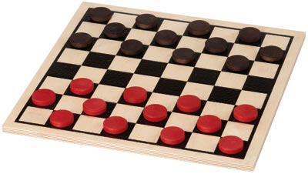

* In addition it helps to improve the logical thinking of the person.
* Besides it helps for the disabled person to get interact with people.
* Our main struggle is to encourage them to live the life in an enjoyable manner.

2.3 Design of the Application

6

* Game consists of features like
  + - As there is a voice recognizer, game can be played in English using simple commands.
    - The game can be played with multi player.

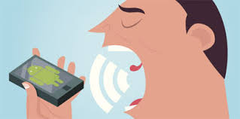

* The game can be played according to the coordinates in the checker board using voice commands.

Ex: **Go to A1 B2**

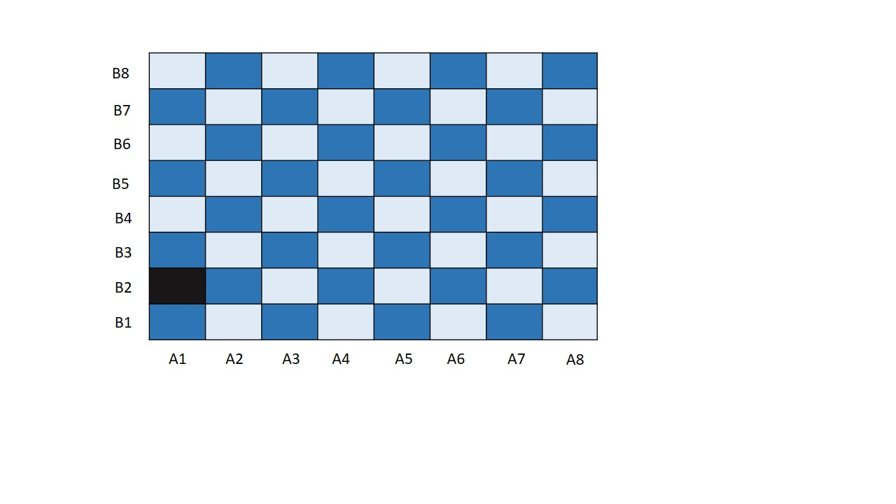

2.4 Business Value

7

* According to the department of census and statistics 87 per 1000 people are disabled in Sri Lanka. So that it’s going to be a demanding need from the society.

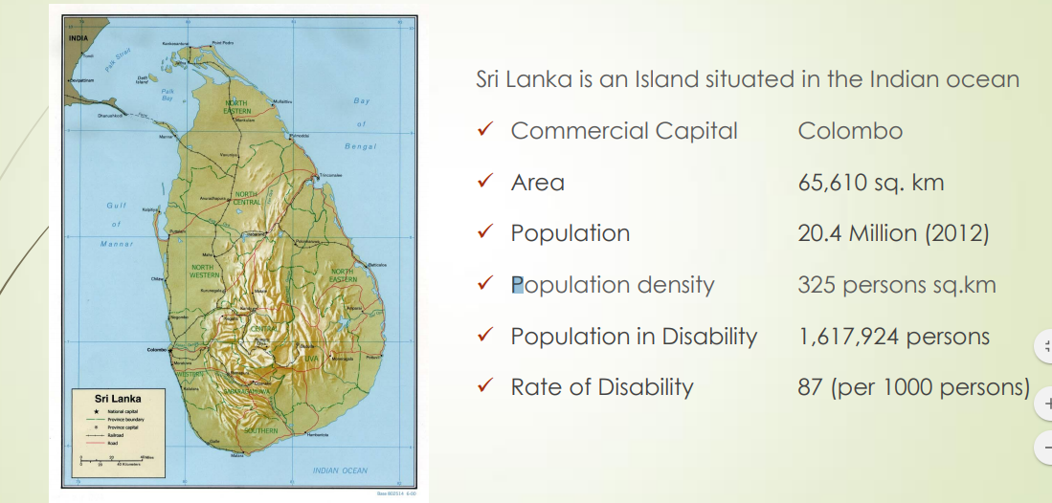

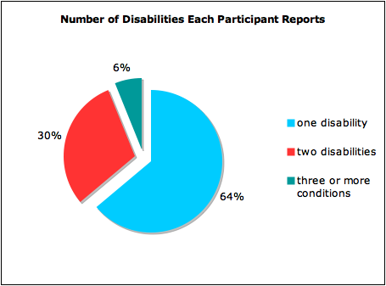

* This problem has a big impact on all around the world. Therefore we can introduce this solution to other countries also if needed.

Lab Assignment – 03

8

* We are designing a checker game which can be played using voice recognition.
* This game is designed mainly focusing on the disabled people.
* It can be played by anyone without considering the age.
* This basically improves the logical thinking and the mental health of the person.

3.1 Business Goals

* **Cost Efficiency**

As we are using voice recognition option, it is simply available (microphone) in any device (Laptops, Mobile phones).So there is no additional cost for hardware .

As the application can be developed within a low budget it fulfils cost efficiency.

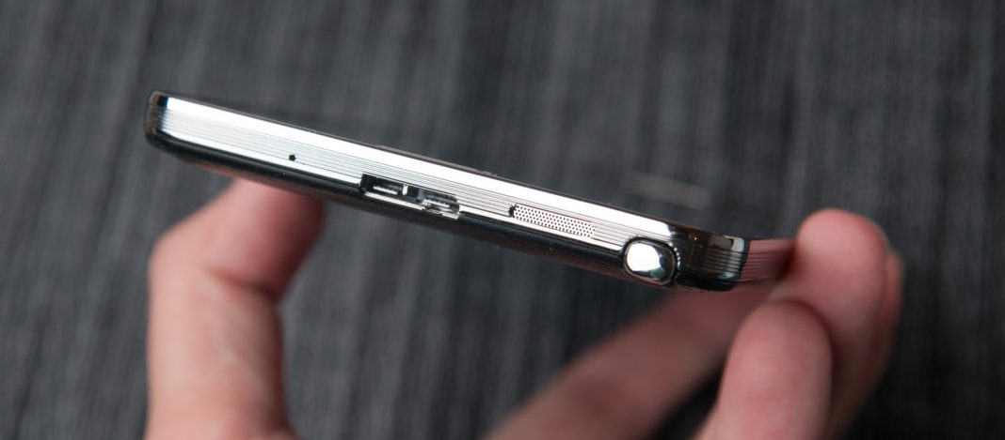

* **Non – Profitable**

9

We design this game app for disabled people as a voluntary work. We do not charge any fee for playing this game. The upper levels of this game can also be played freely.

So basically this checker game is non – profitable.



* **User Satisfaction**

As the users can play this game by themselves without the help of others, they feel confident. And also it helps to improve the logical thinking and the mental health of that person.

So the user satisfaction is also fulfilled.

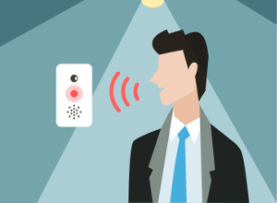

3.2 Competitors

10000

Scream Puppy Game App VS Our Checker Game

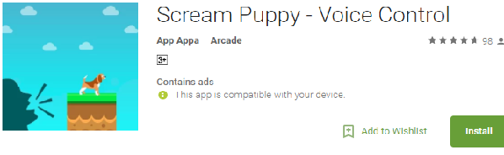

* Even though we need a soft voice, player can see his/her command in a text box as a text.
* To play this game the player need a soft voice for levelling up.
* Here if the player didn’t give the command in soft voice, user don’t know how they detected that command. Therefore they cannot level up the game

Chicken Scream VS Our Checker Game

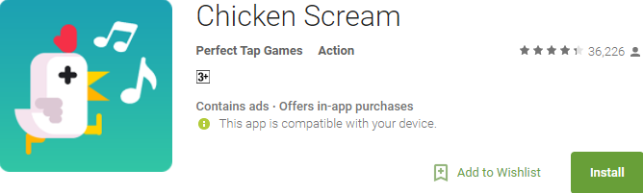

* Playing a game like that is not possible for a disabled person.
* Specially when he/she is sitting in a wheel chair or laying in the bed.
* This checker game does not need any movement of the player.
* It simply need the voice, not even the hard voice like shouting.
* This game can only be played by shouting over the player’s phone.
* Chicken Scream grants you little control over your character,

limiting your movement to walking to the right and jumping.

11000

Son Of Rome VS Our Checker Game

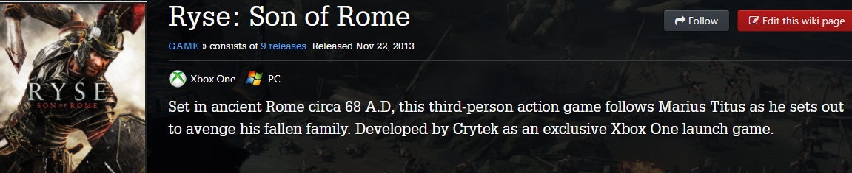

* This is a totally free game.
* The upper levels can also be played freely without any charges.
* To play this game user have to pay and buy this game from amazon or etc.

3.3 User Segments

12000

Customer or User segmentation is the practice of dividing a customer base into groups of individuals that are similar in specific ways relevant to marketing, such as age, gender, interests and spending habits. Customer segmentation, also called consumer segmentation or client segmentation, procedures include:

* Deciding what data will be collected and how it will be gathered
* Collecting data and integrating data from various sources
* Developing methods of data analysis for segmentation
* Establishing effective communication among relevant business units (such as marketing and customer service) about the segmentation
* Implementing applications to effectively deal with the data and respond to the information it provides
* **Demographic**

Demographic segmentation is market segmentation according to age, race, religion, gender, family size, ethnicity, income, and education. Demographics can be segmented into several markets to help an organization target its consumers more accurately. With this type of segmentation, an organization can categorize the needs of consumers.

One of the main advantages of demographic segmentation is that the information you need is readily available for you. You can pull census data to determine who, where, and how you want to market your product. For example, automobile industries can market their cars to different age groups, income levels, and genders.

Another way that businesses, such as automobile industries, don't miss out on the growing market is by providing employees who are bilingual to work with their customers. It is now very common to see business, TV, and newspapers in Spanish as well as English.

Another advantage of demographic segmentation is customer retention and loyalty. When an organization spends time focusing on its customers and their wants and needs, customers will typically come back for repeat business. In our automobile industry example, customers will come back or recommend their friends and family if they were satisfied with their purchase.

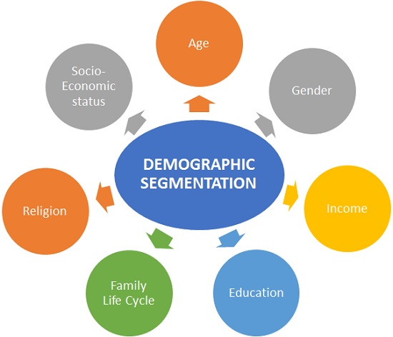

13000

* Customer Characteristics

**Having a one hand VS without both hands**

* Both, a person with a one hand or a person without both hands can play the game in the same way without facing any difficulties.

**Age – Children VS Adult people**

* Can be played by a person with any age range.
* Even the children with the disabilities can use this application.

**Gender – Male VS Female**

* Gender does not effect on playing this game. Can be played by both.

**Educational Level**

* No need to consider whether he/she is a well-educated one or not.
* Even the children with the disabilities can use this application.

14000

**Occupation**

* Occupation of the user hardly related to for this game application. Any disabled person can use.

**Income**

* Income status of the player does not matter for playing this checker game.
* The game is a totally free one and we do not charge to play the levels of this game



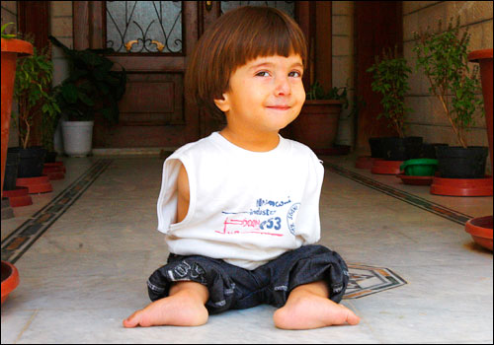

* **Behavioral**

Behavioral segmentation is the act of segmenting your customers based specifically on how they act as consumers. It’s important to note that behavioral data doesn’t exist independently from other segmentation data. A good way to think about it is, behavioral data can often be used to confirm certain conclusions you may have reached when analyzing other segmentation data.

Behavioral segmentation isn’t useful if you’re not targeting the right behaviors.

* Knowledge of the product
* No need to pay to play this game as most of the games do.
* Users can play this game in both ways online and offline.

15000

* Importance is

* Disabled people (specially without having arms) can play this game without feeling any difficulties as there is voice recognition technique.
* Benefits

* Can play whenever they need, whenever they feel alone.
* Can play the game by herself/himself without getting help or disturbing others.
* No need of any movements or hard voice to play.
* It helps to improve the logical thinking of the person.
* Also it increases the mental heath of the person.
* Loyalty

* This goes along with many of the segments we’ve already discussed, such as usage rate, timing
* it’s clear that knowing who your loyal customers are – their needs, their buying habits.
* User Status

* Categorizing consumers by user status segments them into the following categories:
* Non-users
* Prospects
* First-time buyers
* Regular users
* Defectors (ex-customers who have chosen a competitor’s brand)

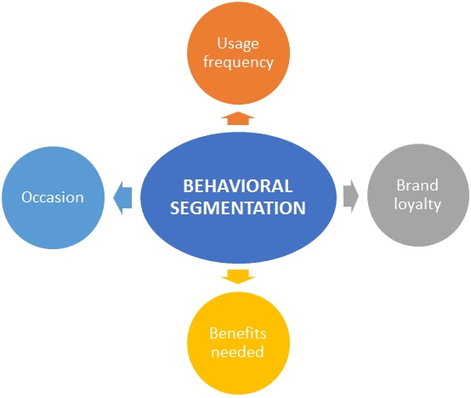

16000

3.4 User Persona

17000

This persona shows the details of a student of age 14 who recently got disabled by an accident. Earlier he spent a normal life like other, going to school, playing with his friends. And one of his targets was to first join the school cricket team and then to the National team.

But the sudden accident caused many difficulties to this small child. Now he has to spend the time in a wheelchair while the other children are playing. Also he is unable to achieve his goals.

So now watching TV, reading books have become his hobbies rather than playing outside with others. He is not in a good condition in both ways, physically and mentally now. Now he worries too much, fears pointlessly and also need the help of others to do his day today activities even.

He misses his friends, school and the life he used to spend so much.

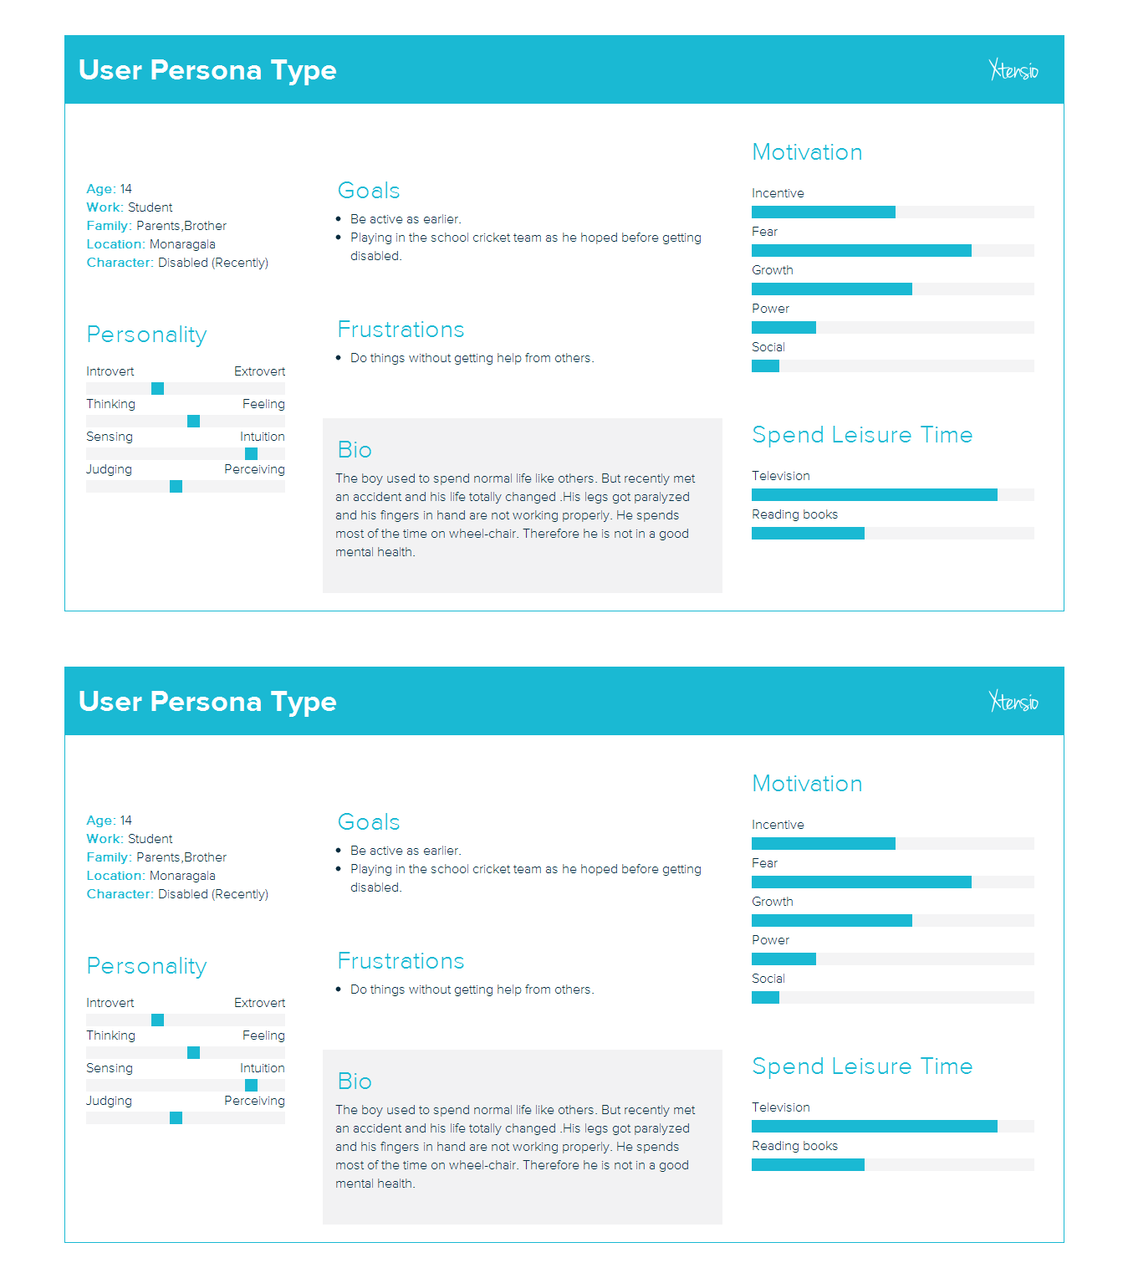

This is regarding a 25 years old married person who was in the Army. He spends a successful marriage life a loving wife and two babies. Also he earlier had a good job, working as a soldier in the army and a good income.

18000

But unfortunately he got shot in the battle field and got injured. Not only that, his legs got paralyzed. So now he spent most of the time in the wheelchair.

He was earlier dreaming of earning a good income and spend a happy life with his family. But he lost his job due to this paralyzed condition. So now he has many financial issues as well as other problems because of his physical condition. Also he is not in a good mental condition because of these issues.

Now he has difficulties of taking care of his own family, looking after his children. He feels guilty about this. He has no money for the needs of his family and for the education of his children. So he feels helpless. He cannot even manage his own work as he is the wheelchair. He misses his early life in the job as a soldier and with friends, and the way he used to protect his own family.

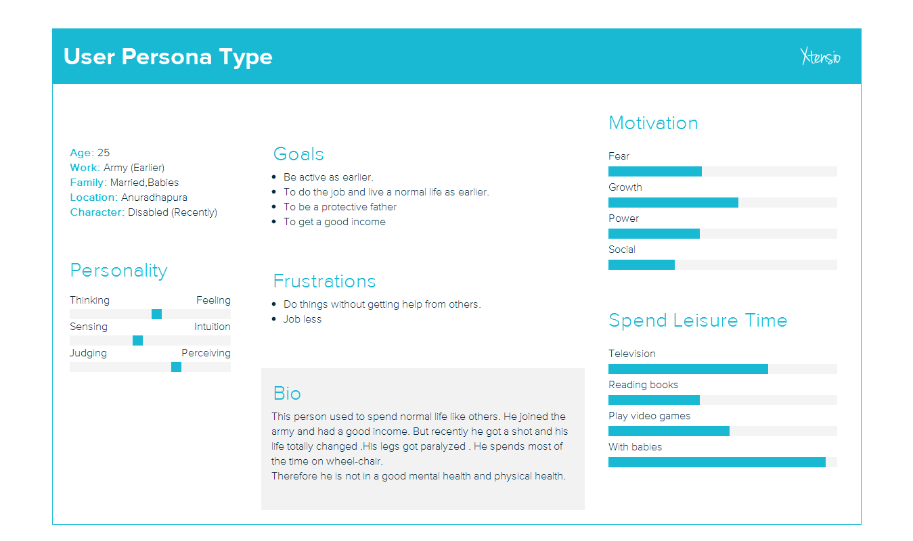

3.5 Conducted Survey Questions

19000

We conducted surveys both in online and offline ways. This is an example for the offline survey that we conducted.

Researches help to uncover, understand and design for real customer needs. And it is about building empathy and understanding the customer needs. It shows us the problem and guide us how to fix the problem.

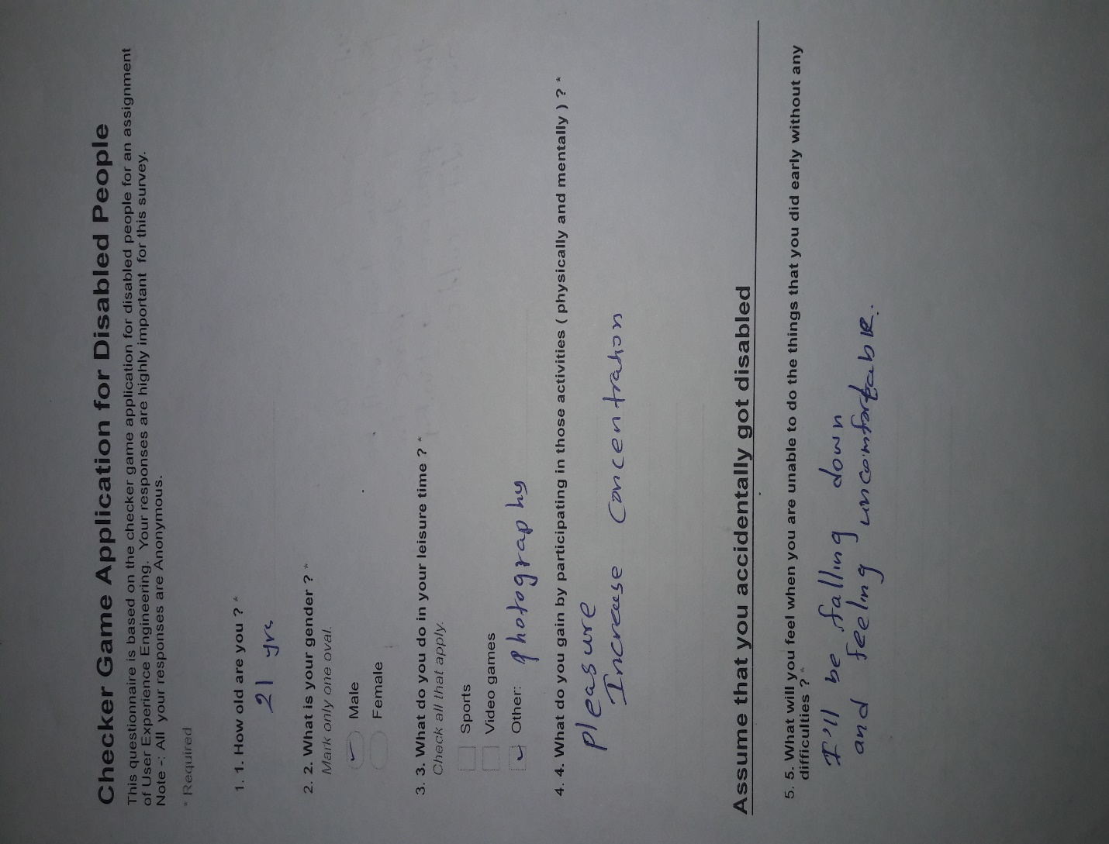

20000

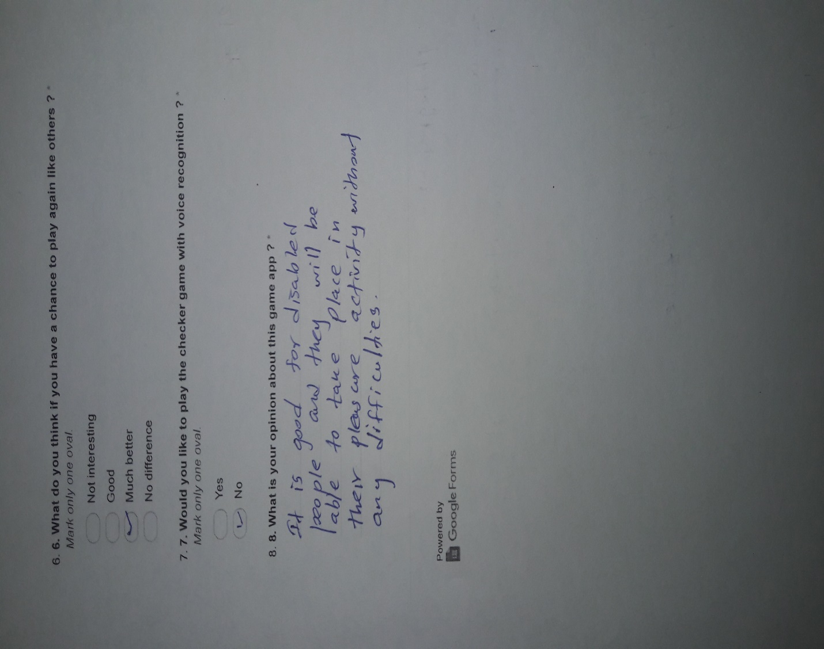

This is only one of the researches that were conducted by us. Others are included in the DVD.

Also the Audio and video interviews conducted with many different people are included in the DVD.

3.6 Survey Results

2100

Online

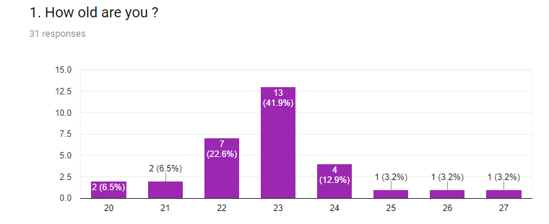

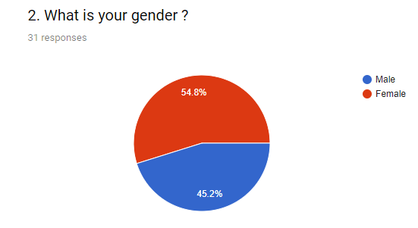

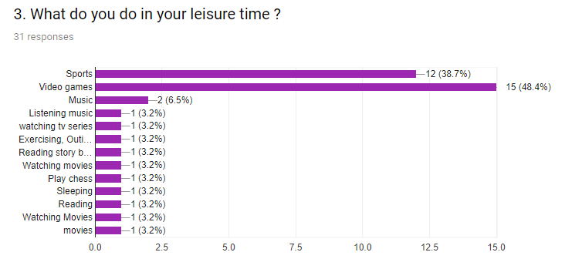

222

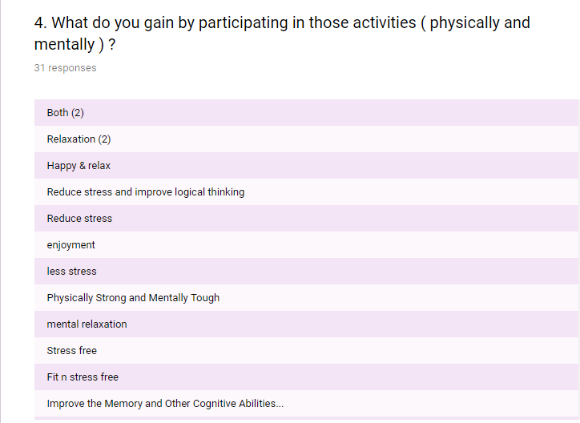

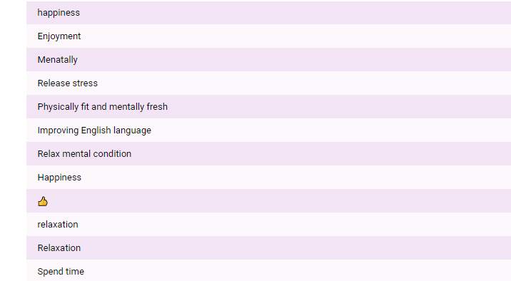

230

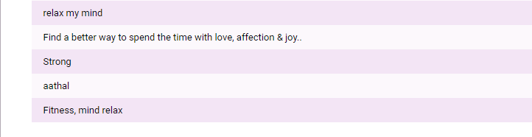

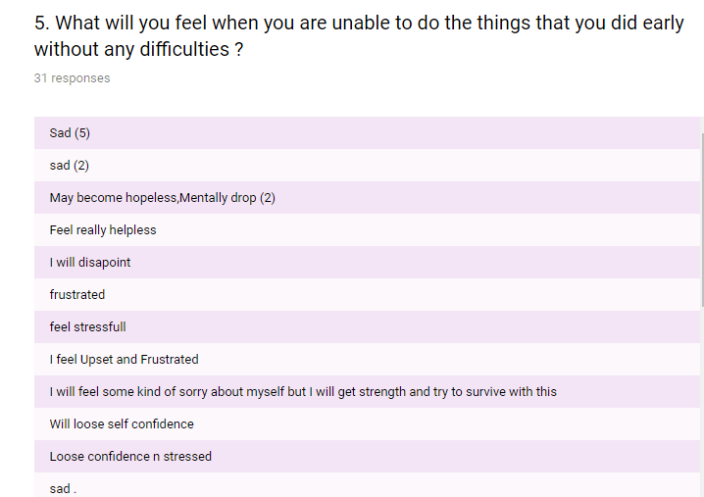

240

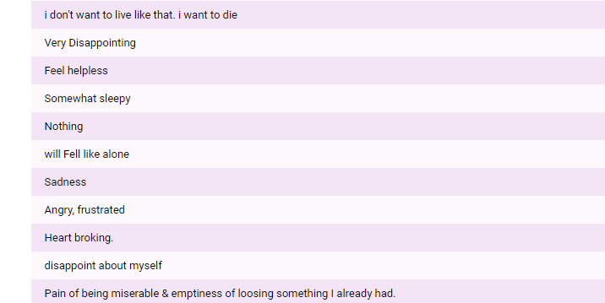

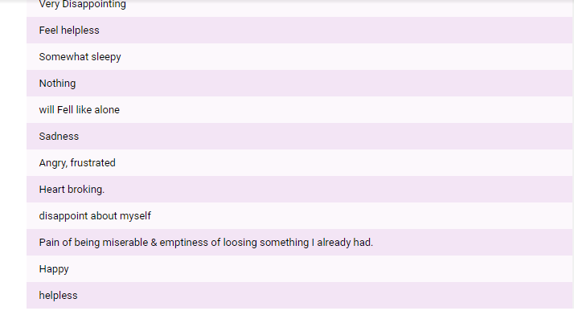

250

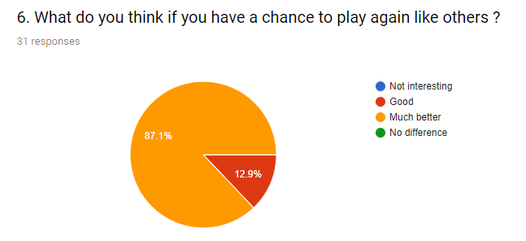

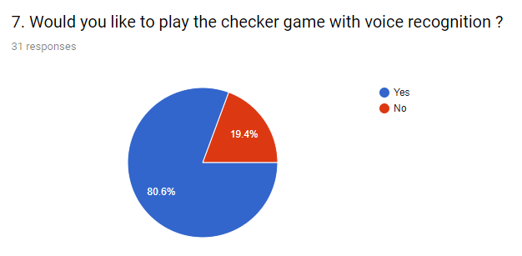

260

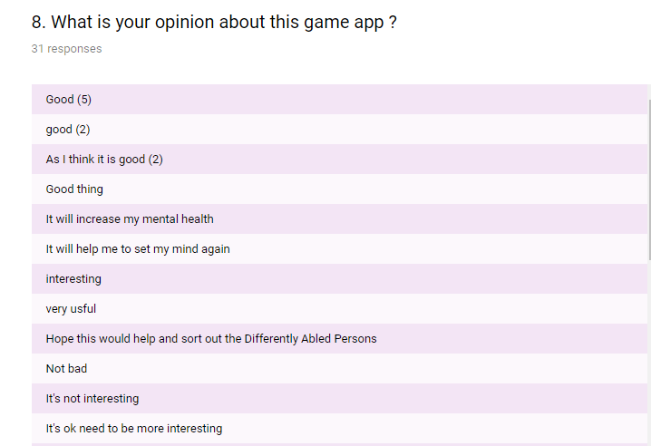

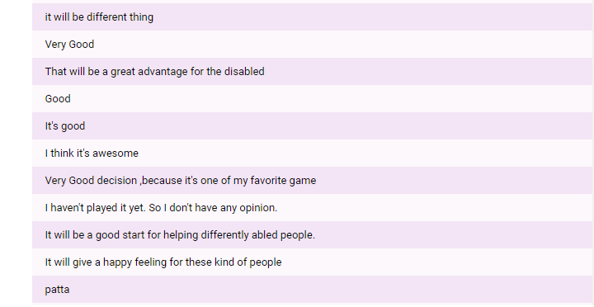

270

3.7 Responses

This show the summary of the online survey conducted by us.

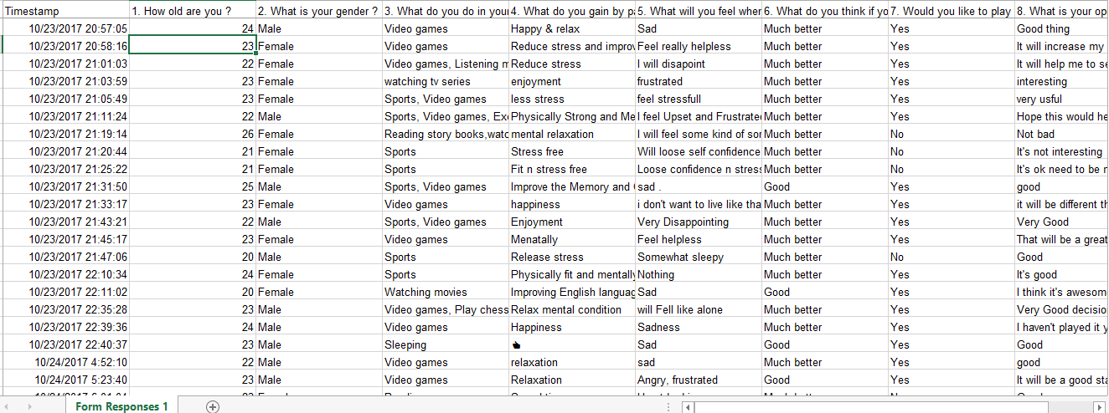

Lab Assignment – 04

280

4.1 Information Structure

First the user has to login to the system, if the user is already logged in he/she can continue without any issue. After successful login then the user can see the main menu of the ‘’Checker Game Application”.

Basically there are few things that can see in the main page. Those buttons are Select Player, Select Level, Select Mode, and Select Board.

Under the Select Player the user can select Player 1 or Player 2.It means the color of your side. Then the player can select the level that he/she wants to play. It means Normal, Medium or Hard level.

We have also given the feature of playing Single Player or Multi Player. So the user can select the Mode which he/she likes to play under Select Mode button which has both Single Player or Multi Player.

After finishing the match player can see the match summary as there is a Score board. When the player clicks on Score board he/she can see the each score of the players separately. And also the player can see who won the particular match.

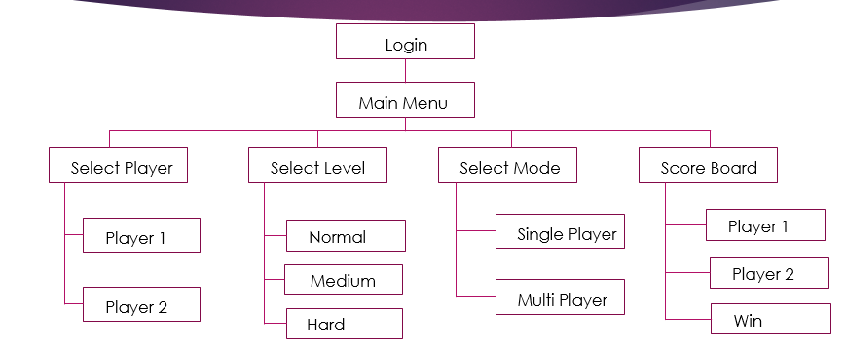

4.2 Conceptual Model

290

A conceptual model is a representation of a system, made of the composition of concepts which are used to help people know, understand, or simulate a subject the model represents. It is also a set of concepts. Some models are physical objects.

We have also used some conceptual models in developing this game.

* In the real world we use a checkerboard and checkers to play the game. In our app use the same concept and use an animated checkerboard with the checkers.

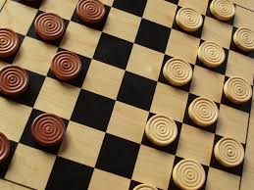

* Usually we play the game with someone in the real world. Here also we use the same concept and have introduced the multiplayer feature.

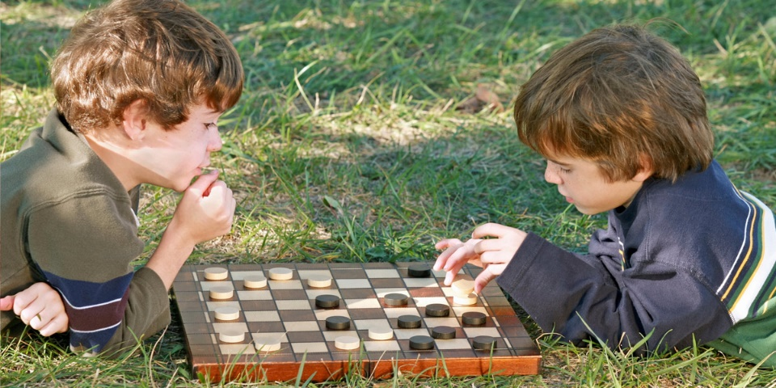

* Normally the game is played by using hands. As we are designing this for the disabled people here we uses the same concept and uses voice recognition mechanism to play the game.

30



4.3 Error Handling Mechanisms

To secure the application we have used some error handling mechanisms. Have prevented information leakage. Error messages give an attacker great insight into the inner workings of an application. Each layer ensures that a higher percentage of users will have positive experience.

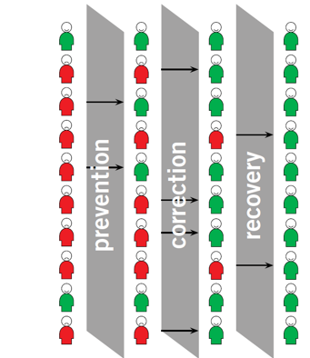

* **Prevention**

31

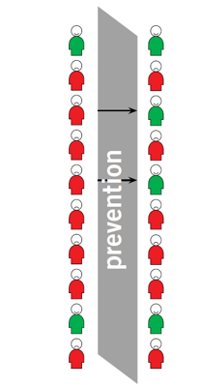

Basically blocking all the ways of that an error can occur.

In the other hand it is making difficult to create an error

or a problem.

* If the player accidently close the app while playing, it will prompt a confirmation box asking whether he/she actually wants to exit.
* If the app detected any wrong command there is a huge probability of moving that checker in to a wrong position. Therefore we get that command into a text and the player can confirm whether the command is correct or not.

Because of this solution we can prevent the error.

* If the player moves a checker of the opposite side (player 1 moves a checker of player 2) the apps give an error message, "It is not your side".
* If the player moves a checker, when it is not the chance of that player (if the player 1 moves a checker in player 2's round), the apps give an error message saying that "It is not your round".

* **Correction**

32

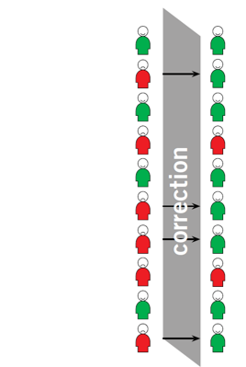

It is the way of providing options to automatically

or manually correct the mistakes done by the user.

* If the player has successfully logged in to the game once, the app automatically generates the password when the player logs again.

33

* **Recovery**

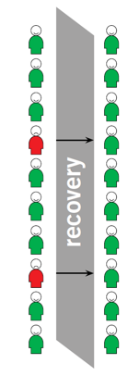

In here it provide the chance to recover or go

back to an error free state.

* If the app detected any wrong command (if not the command that the player gives) there is a cancel option. And the player can again say the correct command.(movement)
* There is an undo button, so if the user entered wrong data (When login) can change that.

4.4 Journey Map

34

Journey maps are a kind of diagram that visualize the actions, thoughts, and feelings of a person or a group over time. Types of journey maps are Current State, Future State, Blueprint, Day in the life.

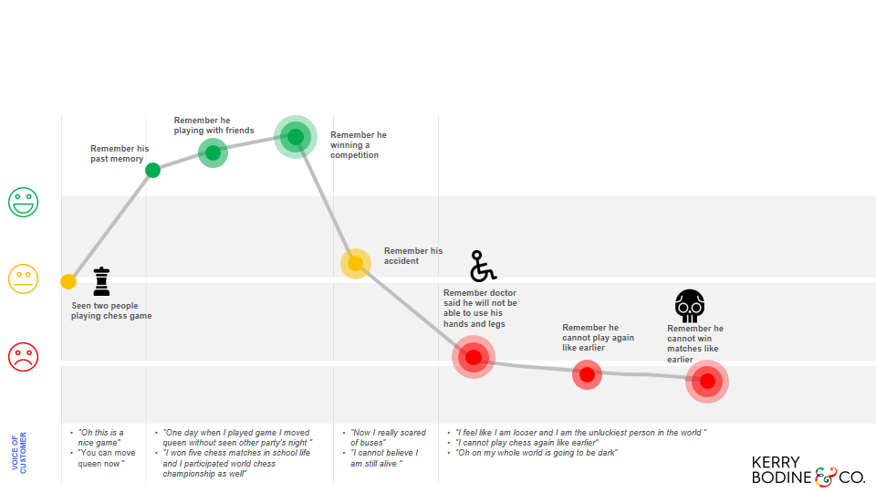

Lab Assignment – 05

35

5.1 Wireframes

Represents a visual guide that represents layout and function. Main purpose of designing wireframes is it focus on the usability and the user experience of the particular application. So simply wireframes are the blueprints.

We design wireframes to communicate (Developer, Visual Designer, User, and Stakeholder), validate (develop a great user experience), save time and costs (Flexible, Valuable).

Can have few different types of wireframes such as Low-Fidelity Wireframes, High-Fidelity Wireframes, High-Fidelity And Annotated Wireframes.

Here are the set of wireframes that we designed for our ‘Checker Game Application’.

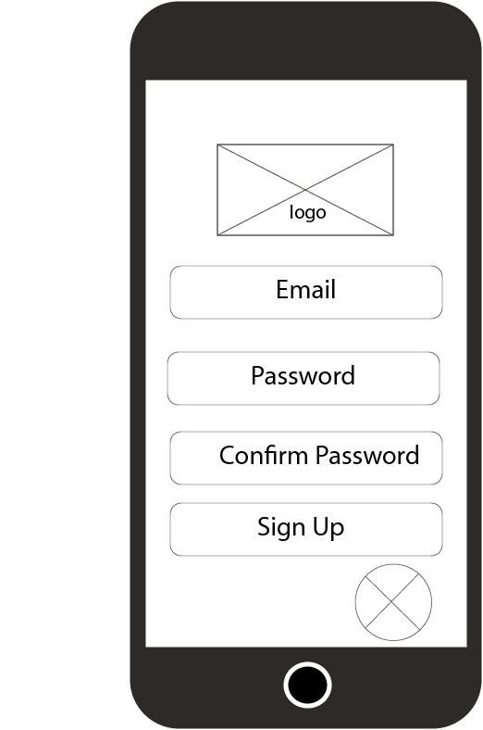

After the user clicks on ‘Checker Game’ he/she prompts to this page. There the user has to login to play the game. Has to enter the email , password and then have to confirm the password. If the user has already logged in to the game he/she can simply click on ‘ Sign Up’ button.

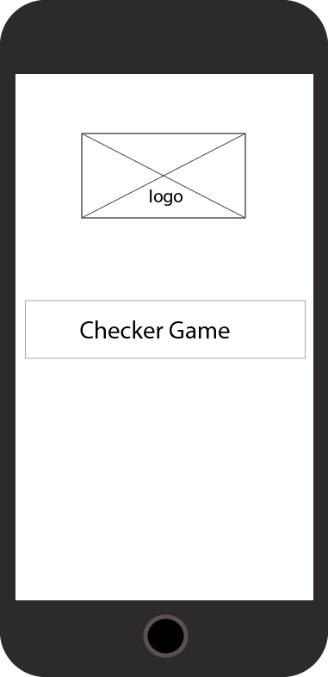

This is the startup window. When the user opens up the ‘Checker Game Application’ he/she can initially see this with our logo.

Click on ‘Checker Game ’ to continue.

36

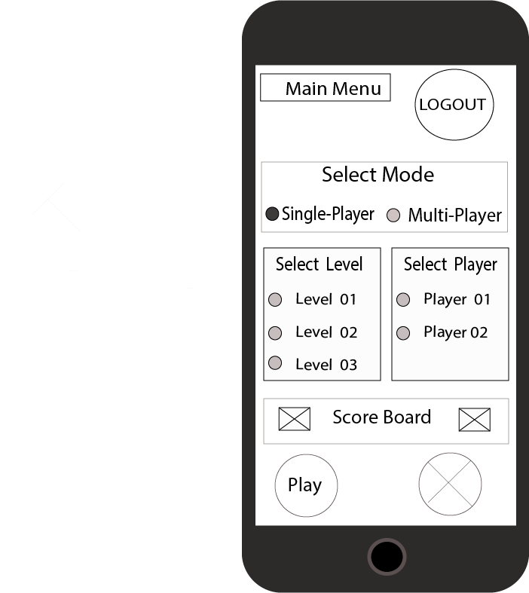

After successful login the user can see the Main menu.

And if needed user can logout as the logout button is there.

To play the game the user has to first select the Mode which he/she wishes to play.

Then the user have to select the Level.

And finally select the Player.

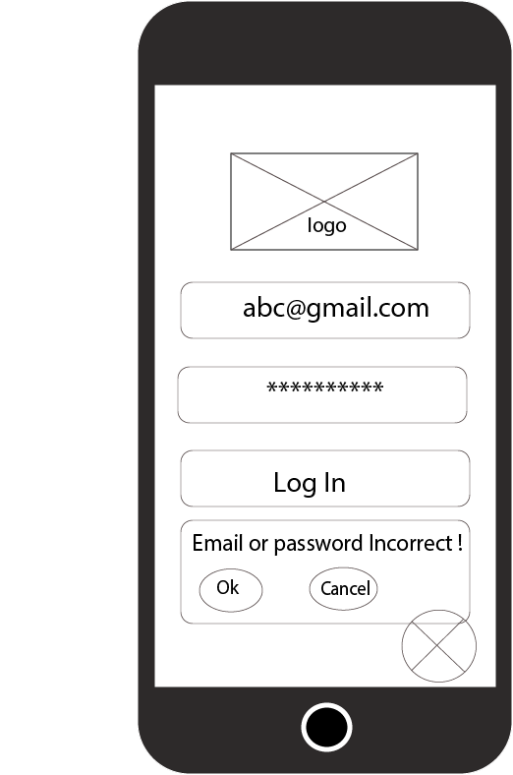

We have used some error handling mechanisms here. (Prevention)If the user entered the wrong password or the wrong email the application prompts a error message saying ‘Email or Password is Incorrect!’

As there is voice recognition feature user does not need to manually type these. Just speaking is enough.

377

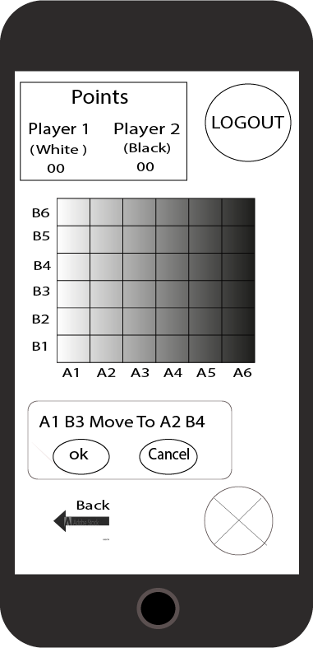

This is the way that the game should be played. User can give any command to move the checker in the above mentioned format.

As there is a back button user can go back if needed.

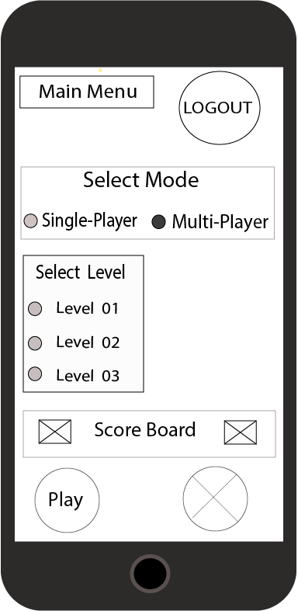

If the user selected the Mode as the ‘Multi Player’ he/she does not have to select the player. Selecting the level is enough.

User can then give the command to play. Then the game will be started.

388

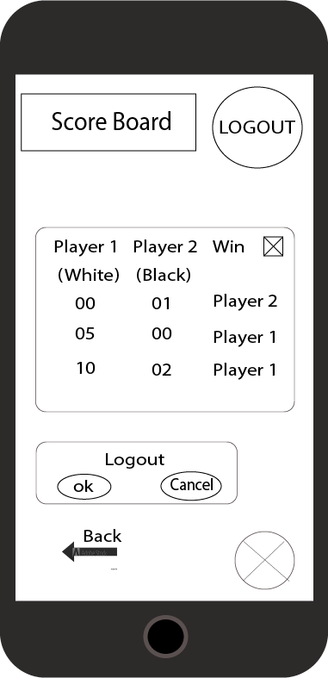

When the player clicks on the ‘Score Board’ he can see the summary of the particular match. Also the score of the each player and the winner of the match.

Finally by clicking logout button user can logout from the game.

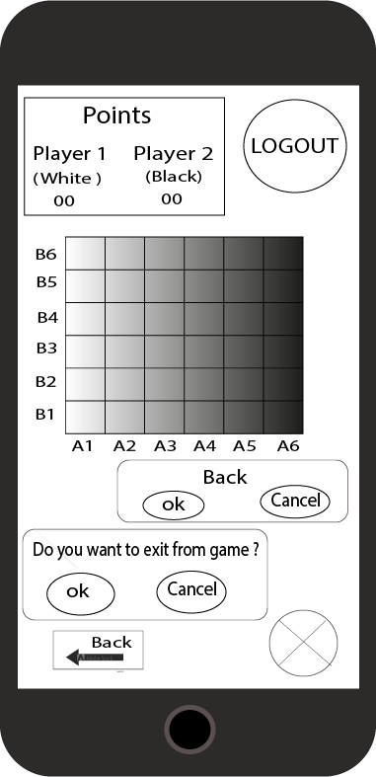

If the user accidently press the back button the app gives a confirmation message asking whether the user actually wants to exit from the game. User can either click ‘Ok’ or ‘Cancel’

5.2 Mockups

39

In manufacturing and design, a mockup, or mock-up, is a scale or full-size model of a design or device, used for teaching, demonstration, design evaluation, promotion, and other purposes. A mockup is a prototype if it provides at least part of the functionality of a system and enables testing of a design.

Here are the mockups that we created for our ‘Checker Game Application’

This is how the application initially looks like.



40

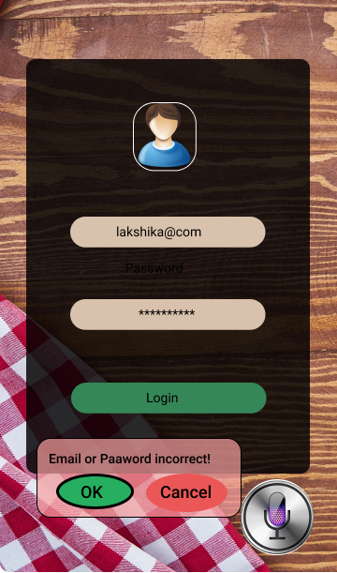

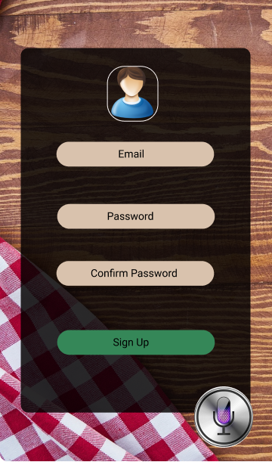

These are the sign up and login pages. When user log into the game, if user enter wrong email or password, it gives error message .

41

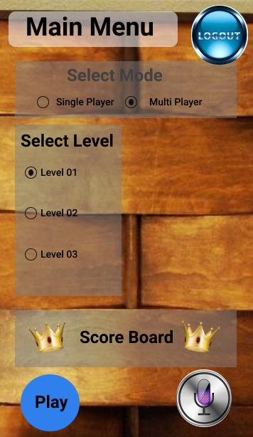

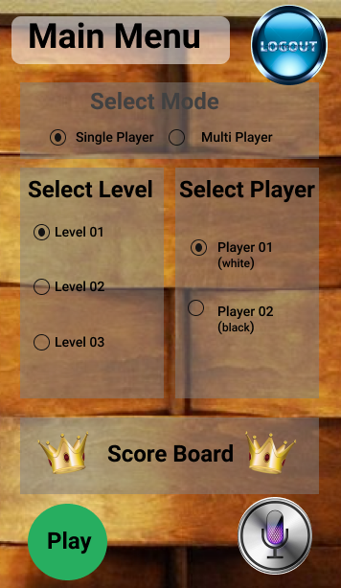

The main menu shows in following designs. The main difference between those two designs is , if user select single player mode, he/she has to select the player. Otherwise user does not need to select the player.

h

42

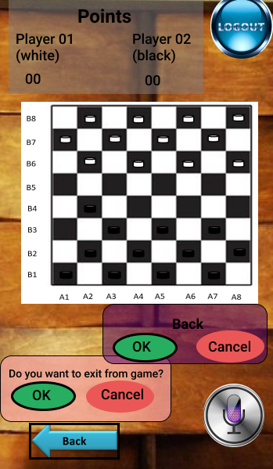

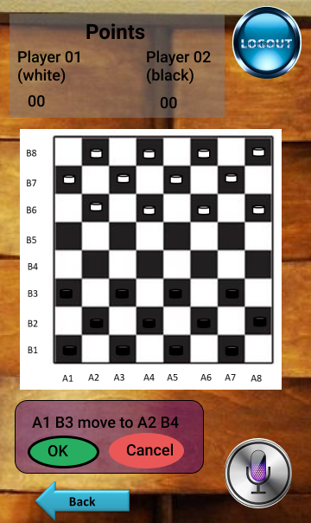

dd

This is the checkerboard which user has to play. Once the player gives coordination to move the checker and confirm it, checker will move. That shows in the left side of the design. As well as that if player wants to exit from the game, player needs to give “back” command and confirm it.

dd

43

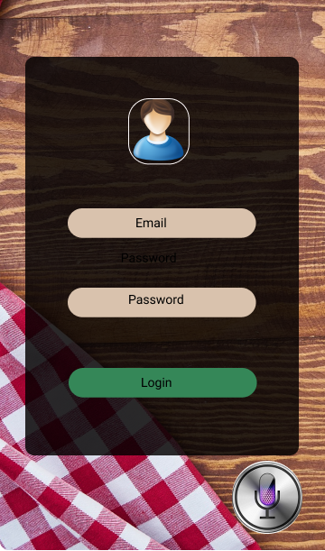

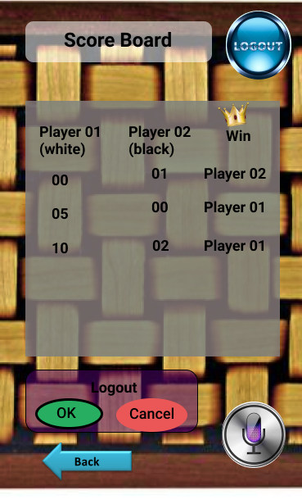

Left side design shows the score board of the players and right side design shows the login page. Once the player exit from the game, player can see the score board. And also if player wants to logout from the game player needs give “logout” command and confirm it. Then it shows the login page again.

6. Suggestions from the user

44

We tested our working prototype with many different people. And we got a feedback regarding the game app that we developed.

Here are some opinions that they suggested.

* It is easier for the user to use the app if there is no login or sign up options. Because sometimes it makes trouble when logging.
* It is more attractive and user friendly if some animation parts were used in designing this game.
* It is better if we can change the command (A1 B3 move to A2 B4) that we use to move the checker, because it is bit longer.